
COMSATS University Islamabad
Sahiwal Campus
(Department of Computer Science)
Course Title: | Artificial Intelligence |  |  |  | Course Code: |  | CSC262 |  | Credit Hours: | 3
Course Instructor: | Ms. Kanwal Fatima |  |  |  | Programme Name: |  |  | BCS
Semester: | 5 | Batch: |  | Section: |  |  |  | Date:
Time Allowed: |  |  |  |  | Maximum Marks: |  |  |  | 10
Student’s Name: |  |  |  |  | Reg. No. | CUI/ /SWL
Lab Assignment 1
Question 1: CLO 6
Students are required to apply web scraping to collect relevant information from a website, process this data for a practical use case, and develop an interactive front-end for user interaction.
The first step is to perform web scraping using Python libraries such as BeautifulSoup or Selenium to extract useful information from a chosen website. The extracted data should be processed and stored in a structured format.
The second step is to utilize the extracted data in a meaningful application. The application should perform some analysis, comparison, or decision-making based on the scraped data. For example, students can extract admission eligibility criteria from a university website and compare it with user-provided academic marks to determine eligibility, or extract real-time weather data and display personalized weather alerts.
The final step is to develop a front-end interface using Streamlit, Flask, or Django. The interface should allow users to interact with the data, input necessary details, and view the processed results in a user-friendly manner.

Question 2: CLO 6
Write Python code to draw the following graph using matplotlib (or any other relevant library):
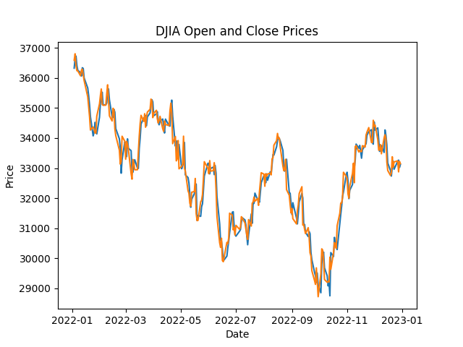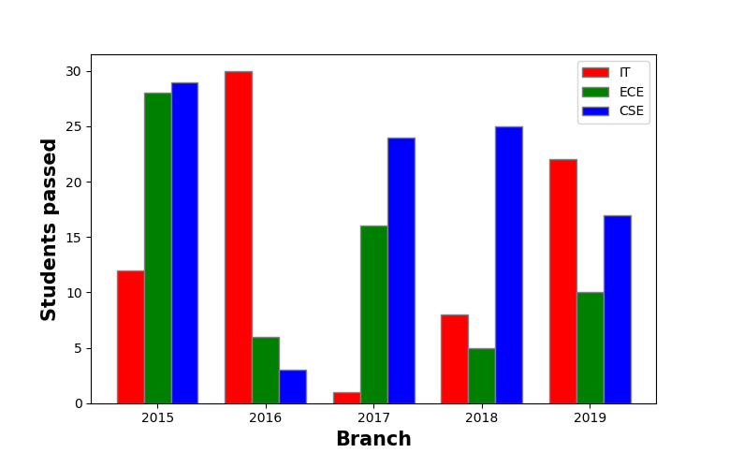
Question 3: CLO 6
Develop a Tic-Tac-Toe game in Python using NumPy for game logic and Streamlit for the graphical interface. The game board should be created using np.zeros((3,3), dtype=int), where 0 represents an empty cell, 1 represents Player 1 (X), and 2 represents Player 2 (O). Implement a nested loop to check for a win, draw, or ongoing game status, ensuring that players take turns marking their moves.
The game should have an interactive front-end built using Streamlit, allowing users to click on cells to make a move. The interface should update dynamically to reflect player actions and display game status messages such as "Player 1's turn" or "Player 2 wins!". Additionally, implement a simple AI opponent so that a player can compete against the computer. A "Restart Game" button should be included to reset the board after a game ends.
Submit a Python script named tic_tac_toe.py, ensuring that the code is properly documented and includes a brief explanation of the approach used.

